Terms:
Binary Mask: used for image segmentation, used to define ROI.
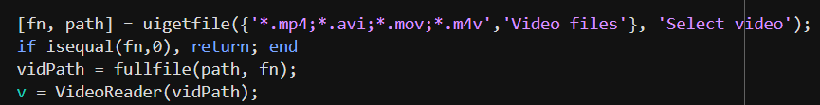 | [fn, path] = uigetfile returns the file name and path when the user clicks Open. if they click Cancel, it returns a 0 for both outputs, program stops.  If file selected is not a video, also returns end.  VideoReader in MATLAB relies on your operating system’s media framework (Windows Media Foundation on Windows, QuickTime on macOS, GStreamer on Linux) to decode videos.
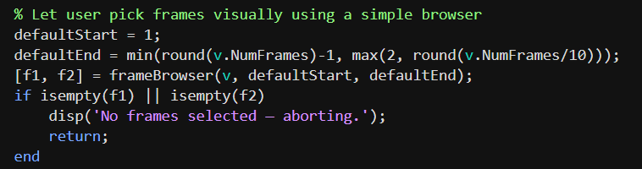 | Default Start frame 1, end frame at least 2, at most total number of frames/10  Aborts if no frame is selected for either start or end frame.

Measure_frame function
Function Name is measure_frame, output is props, custom output structure.

props, structure that gets defined in line 30.
Reads the video frame
Converts to grayscale image.
Opens a figure window with given properties, and framerate.

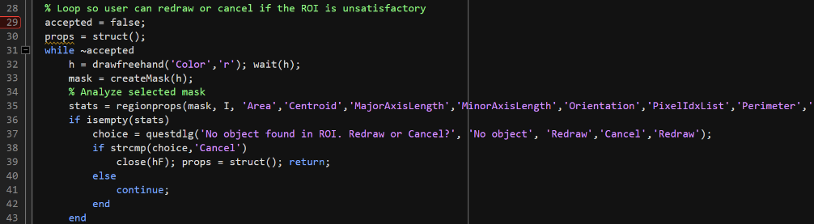 | START Loop – prompts user if they want to confirm their choice of ROI.  stats = regionprops(regions,I,properties) also measures pixel value properties for each labeled region in the grayscale image I.
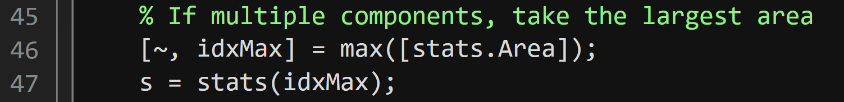 | If multiple components drawn on frame, the only component chosen is the one with max area.  - Final fail safe, obscelet in this version of the code.
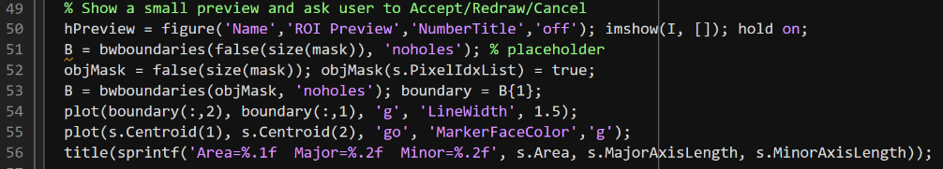     | imshow(I, []) displays the grayscale image I (the current frame of the video).  The empty brackets [] tell MATLAB to automatically scale display intensity to the image range.  hold on allows plotting additional elements (like boundaries) on top of the image without clearing it.  The handle hPreview stores the figure reference for later use (so it can be closed or modified programmatically).  false(size(mask)) creates a blank binary image of the same size as mask, filled entirely with false (no pixels set).  'noholes' means only external object boundaries are found — interior holes are ignored.  “Find only the outermost boundaries of connected white regions, and ignore any holes inside them.”  This creates a binary mask (objMask) the same size as the user’s drawn ROI (mask).  It sets the pixels belonging to the detected object (from regionprops s) to true.  s.PixelIdxList is a list of all pixel indices that make up the object.  So now objMask is true only where that object exists.  Bwboundaries traces outline of the object in binary mask. B{1} is Nx2 cell array, describing the contour of the object. Boundary is the array of pixels of border pixels.  Plot boundary with green line and centroid
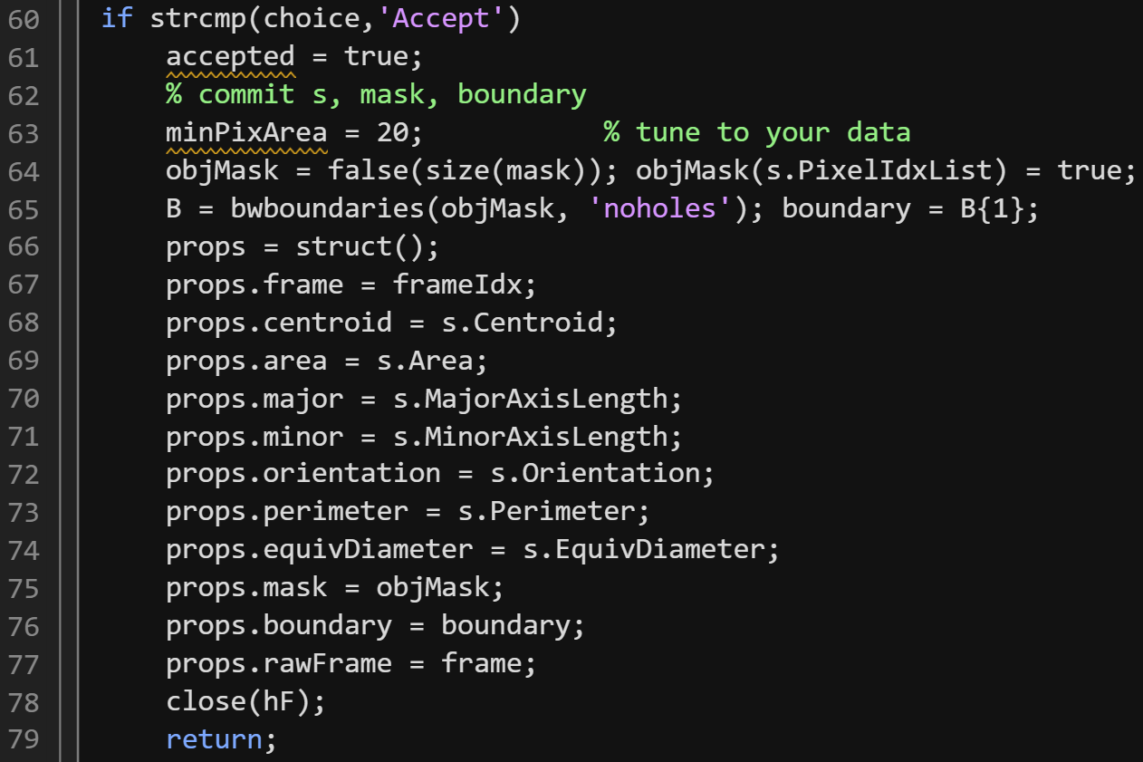  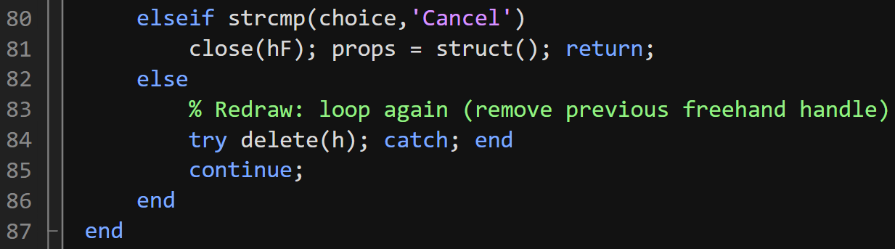 | END LOOP  Choice to accept or reject user drawing of ROI.
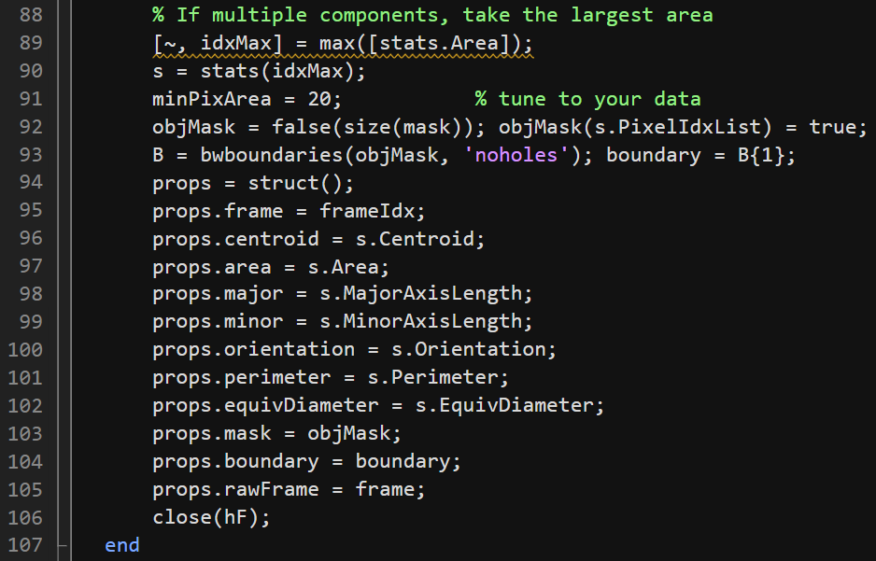 | ‘tune your data’ not relevant in this version of the code.  Loop Failsafe  Line 94, recreates structure to hold data to make sure that if there are multiple components, it only takes the largest area.  End Function

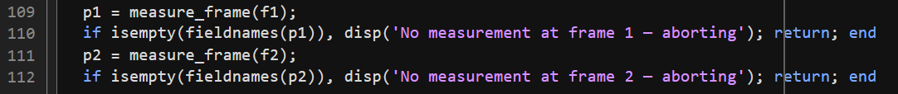 | Runs two selected frames through our measure_frame function
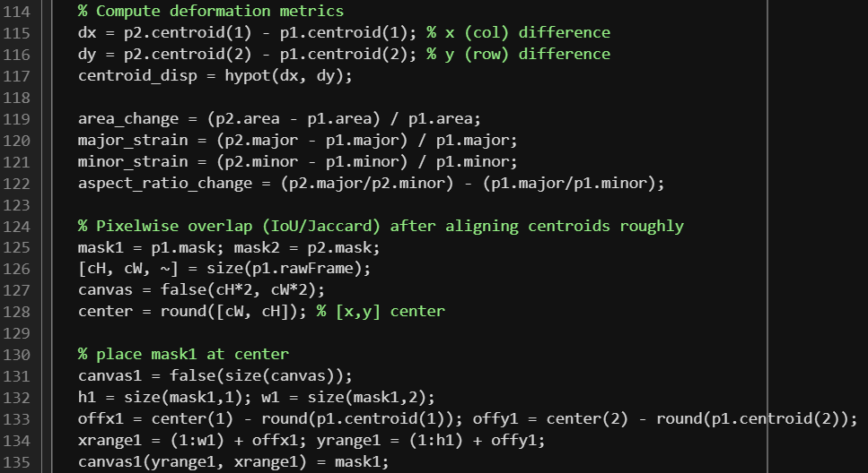 | Computations  Major vs minor axis
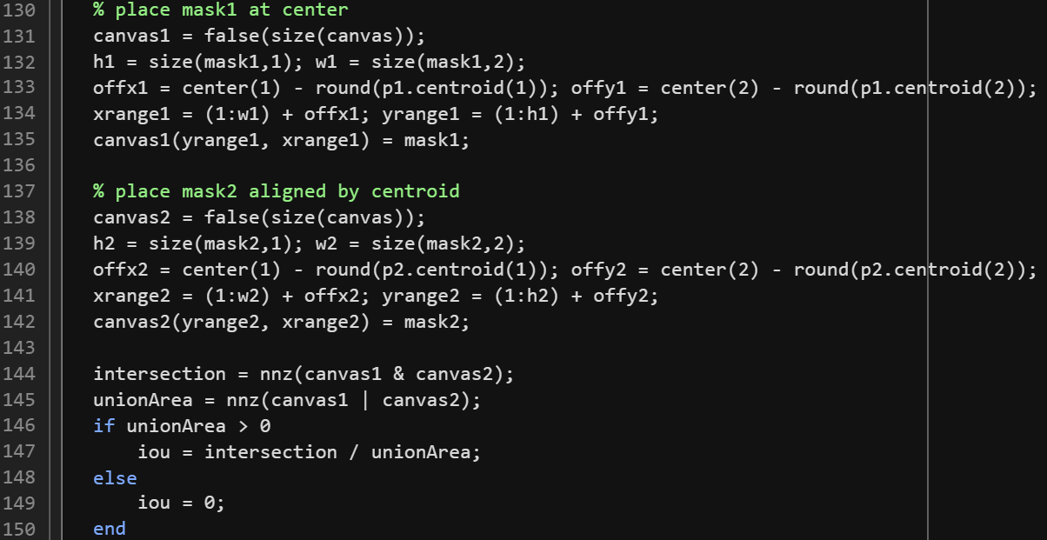 | how much two segmented objects (from two seperate frames) occupy the same pixel regions in the image.  High overlap (IoU) shows minimal deformation from point a to point b.  H1/h2 detects number of rows of pixels calculated to determine height  W1/w2 detects number of colums of pixels to determine width.  Intersection is canvas1 & canvas2 is new binary image where a pixel is 1 only if that pixel was 1 (cell) in both frames.  Nnz is function that returns the number of non-zero elements.  iou means intersection over union.  Another metric of deformation.  UnionArea is total area of EITHER canvas1 or canvas2.  UnionArea > 0 check to make sure we aren’t divinding by 0.
 | Results display in Command Window. Not currently output to a file.
 | UI stuff for end display.
Frame browser

UI for frame selection.

Positive changes show cell stretching, negative changes show cell compacting/shrinking.

